- \Operation\Tube filling\Weight settings (page 1 of 2)
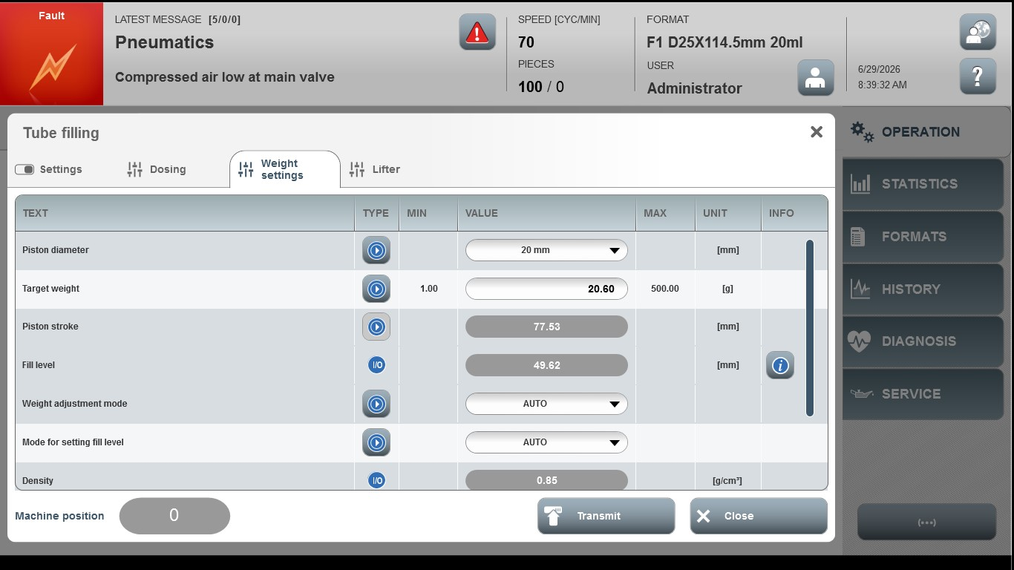
Acceptance criterion | Limits | Pass / Fail: Dev-No. | Date | Initials
Screen matches screenshot | N / A
Target weight | 1.00 … 500.00

- \Operation\Tube filling\Weight settings (page 2 of 2)
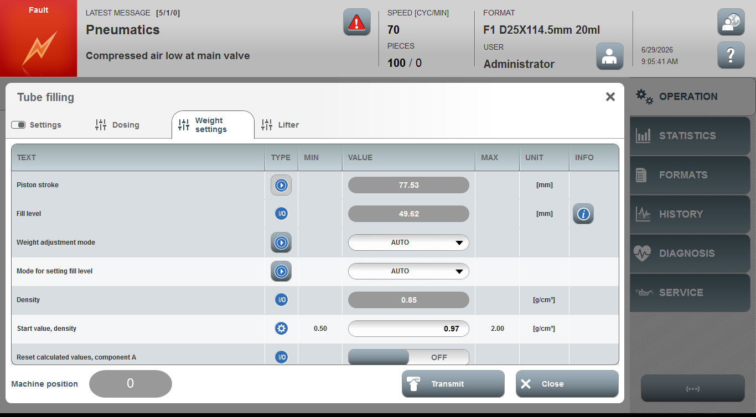
Acceptance criterion | Limits | Pass / Fail: Dev-No. | Date | Initials
Screen matches screenshot | N / A
Start value, density | 0.50 … 2.00

